Vacuum Systems: A Guide to Turnkey Projects

When it comes to implementing vacuum systems in industrial settings, the route you take can significantly impact the efficiency, cost, and success of your project. Turnkey projects offer a streamlined solution, with a single company managing the entire process from conception to completion. While there are numerous advantages, it is important to also consider potential drawbacks and how to mitigate them. This guide explores how to enhance the benefits of a turnkey vacuum system project whilst mitigating potential drawbacks.

Benefits of turnkey projects
One-stop shop
Turnkey projects provide convenience by allowing customers to work with a single company, avoiding the need to coordinate with multiple suppliers and contractors. This saves time, reduces confusion, and streamlines the project process. Your supplier should serve as the single point of contact during a turnkey project, ensuring a cohesive and seamless experience from start to finish.

Reduced costs
Turnkey projects often result in lower costs because solution providers typically have strong supplier relationships and greater buying power, allowing them to negotiate better prices. Additionally, fixed-cost turnkey projects help mitigate financial uncertainties. Look for a supplier that can offer cost-effective solutions by handling all aspects of the project for a fixed fee.

Reduced lead time
Turnkey projects are usually faster to complete because design, procurement, and construction can occur concurrently. This allows customers to benefit from their investment sooner. A supplier with comprehensive project management capabilities will help to reduce project timelines, delivering results efficiently.

Improved quality
Turnkey projects often result in improved quality because the responsible company has control over both design and construction, minimizing the misunderstandings or mistakes that often arise when multiple providers are involved. With this comprehensive control, the final system consistently meets and frequently surpasses customer expectations, delivering a vacuum system of exceptional quality.

Single point of responsibility
A single company being responsible for the finished product reduces the risk of finger-pointing or blame-shifting. Your supplier should take full accountability for project results, providing customers with peace of mind and a reliable point of contact for any issues that arise.

Common concerns and misconceptions about turnkey projects
Limited control
Customers might feel they have limited control over the design and construction process in turnkey projects. A competent supplier should address this by including a detailed consultation and analysis to ensure all needs are understood, followed by a collaborative design process where local engineers design the solution in close cooperation with the customer.

Reduced flexibility
Turnkey projects can be less flexible, making changes difficult once the project is underway. To mitigate this, look for a supplier with a project philosophy that prioritizes flexibility, provides prompt feedback, and presents options for any change requests to keep the project moving efficiently.

Dependence on turnkey solution provider
Customers depend on the turnkey provider for a high-quality, reliable solution. If the provider fails to deliver, they may face subpar results or need to restart the project entirely. To ensure optimal vacuum system performance, choose a supplier with highly skilled experts, advanced sizing tools, and a proven track record of successful installations for the customer’s application and industry. This ensures both reliability and peace of mind throughout the process.

Value for money of subcontracting project management
While handling projects internally may seem cost-effective, it’s important to consider the hidden costs of doing so. Opting to manage key projects in house may divert employees from their core activities, potentially reducing productivity in essential business areas. Moreover, in-house teams may lack the specialized skills, experience and resources needed to handle complex vacuum system projects efficiently. Subcontracting project management to an experienced supplier allows businesses to leverage expert knowledge, tools, and industry-specific experience, ultimately leading to a more streamlined project process and fewer unforeseen issues.

Difficulties achieving the ideal project scope
Turnkey projects can limit scope options if a supplier is reluctant to customize solutions. A collaborative approach ensures that customers have control over defining the project scope, optimizing value, and tailoring solutions to specific needs. Additionally, customers can often find selecting the best solution for their needs challenging. Consider choosing a supplier that can demonstrate the value of any options presented through return-on-investment calculations, showcasing the efficiency and effectiveness of each.

Lack of transparency during design and construction
Turnkey projects can sometimes lack transparency, making it difficult for customers to understand progress. A collaborative approach to projects includes clear communication and regular updates throughout all stages, particularly during the design and build process.

Conclusion
In conclusion, turnkey vacuum systems offer a practical and efficient approach for businesses seeking to optimize their operations. By streamlining processes, reducing costs, and providing a single point of accountability, turnkey solutions address many of the challenges associated with complex industrial projects. However, the success of a turnkey project depends significantly on choosing a partner that balances efficiency with flexibility, collaboration, and a commitment to quality.
As a leader in turnkey vacuum solutions, the global Busch Group is uniquely positioned to deliver on these promises. Busch has a comprehensive approach that encompasses the full project lifecycle, from initial design consultation through to installation and beyond, ensuring that every detail aligns with client needs and industry standards. With extensive experience, advanced engineering tools, and a global track record of successful implementations, Busch ensures high-quality outcomes that meet clients’ operational demands and exceed expectations. By choosing the Busch Group – comprising the portfolio of its three brands Busch Vacuum Solutions, Pfeiffer Vacuum+Fab Solutions and centrotherm clean solutions – customers gain not only a turnkey solution but also a dedicated partner, capable of maximizing the efficiency, reliability, and overall value of their vacuum system projects.

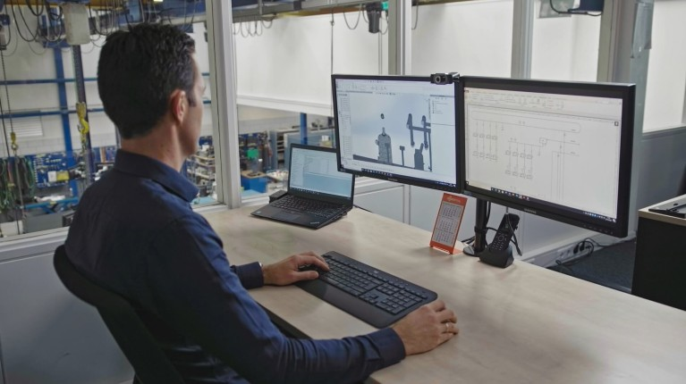
Turnkey vacuum systems from conception to completion offer a practical and efficient approach for businesses seeking to optimize their operations. Source: Busch Group.

About the Busch Group
The Busch Group is one of the world’s largest manufacturers of vacuum pumps, vacuum systems, blowers, compressors and gas abatement systems. Under its umbrella, the group houses three well-known brands: Busch Vacuum Solutions, Pfeiffer Vacuum+Fab Solutions and centrotherm clean solutions.

The extensive product and service portfolio includes solutions for vacuum, overpressure and abatement applications in all industries, such as food, semiconductors, analytics, chemicals and plastics. This also includes the design and construction of tailor-made vacuum systems and a worldwide service network.

The Busch Group is a family business that is managed by the Busch family. More than 8,000 employees in 44 countries worldwide work for the group. Busch is headquartered in Maulburg, Baden-Württemberg, in the tri-country region of Germany, France and Switzerland.

The Busch Group manufactures in its 19 own production plants in China, the Czech Republic, France, Germany, India, Romania, South Korea, Switzerland, the United Kingdom, the USA and Vietnam.

The Busch Group has an annual consolidated revenue of close to 2 billion Euro.

Media Contact
Dr Fabian Fahlbusch
Head of Content and Communications
Busch Vacuum Solutions
Schauinslandstrasse 1
D-79689 Maulburg, Germany

+49 (0)7622 681 - 3379
fabian.fahlbusch@busch.de
www.buschvacuum.com
www.buschgroup.com

