No High-Quality Porcelain Without Vacuum.
KPM Königliche Porzellan-Manufaktur Berlin GmbH | KPM Royal Porcelain Factory Berlin GmbH

For over 40 years, three vacuum pumps from Busch Vacuum Solutions have been in service at the Königliche Porzellan-Manufaktur in Berlin. They ensure that every new product meets the high quality requirements of the traditional manufacturer founded in 1763 by reliably degassing the porcelain.

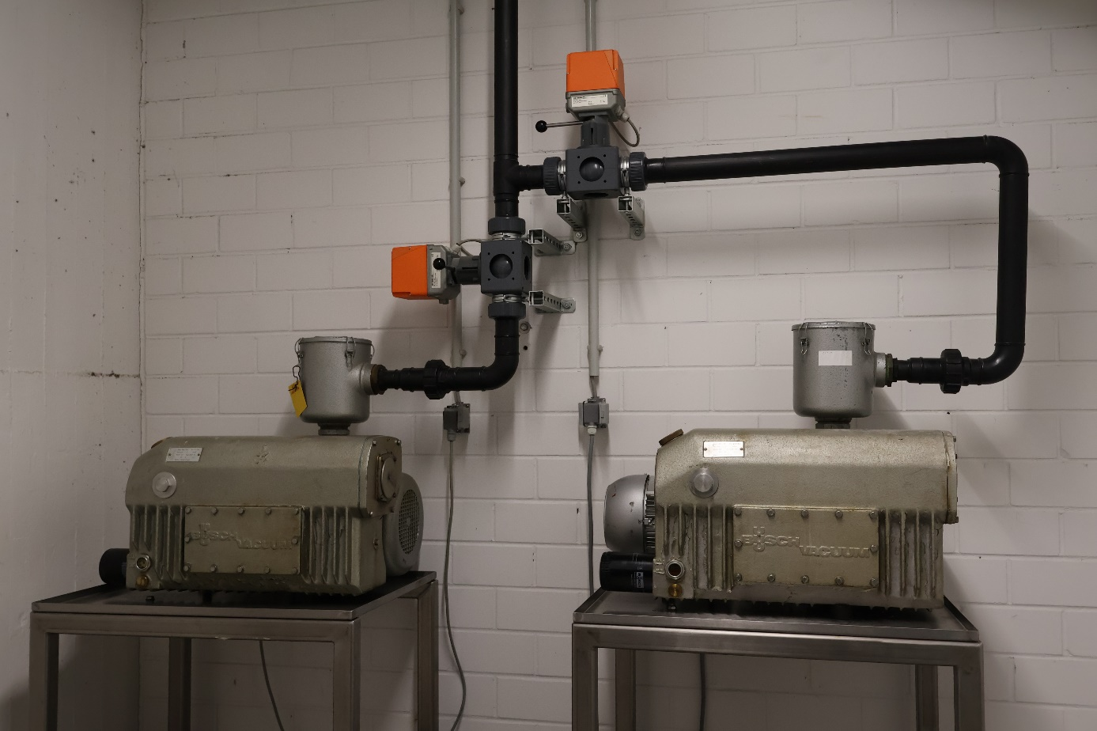
Two R5 rotary vane vacuum pumps from Busch ensure the correct vacuum level for degassing the porcelain before further processing. Source: Busch Vacuum Solutions.

A labyrinth of seemingly endless corridors and staircases in an exemplary restored brick building from 1870 in the heart of the German capital. There they stand behind a blue door in a small, clean room: two R5 rotary vane vacuum pumps from Busch Vacuum Solutions. The vacuum they have been reliably generating here for decades is required in the neighboring room. It is needed to effectively degas porcelain.

Three ingredients for endless creativity

The traditional recipe for porcelain consists of half kaolin and a quarter of feldspar and quartz. These raw materials are supplied pre-ground in large white bags, mainly from mines in Bavaria and Saxony. Today, the factory's 180 employees process 150 tons of these materials into 200,000 individual products a year – from espresso cups to floor vases.

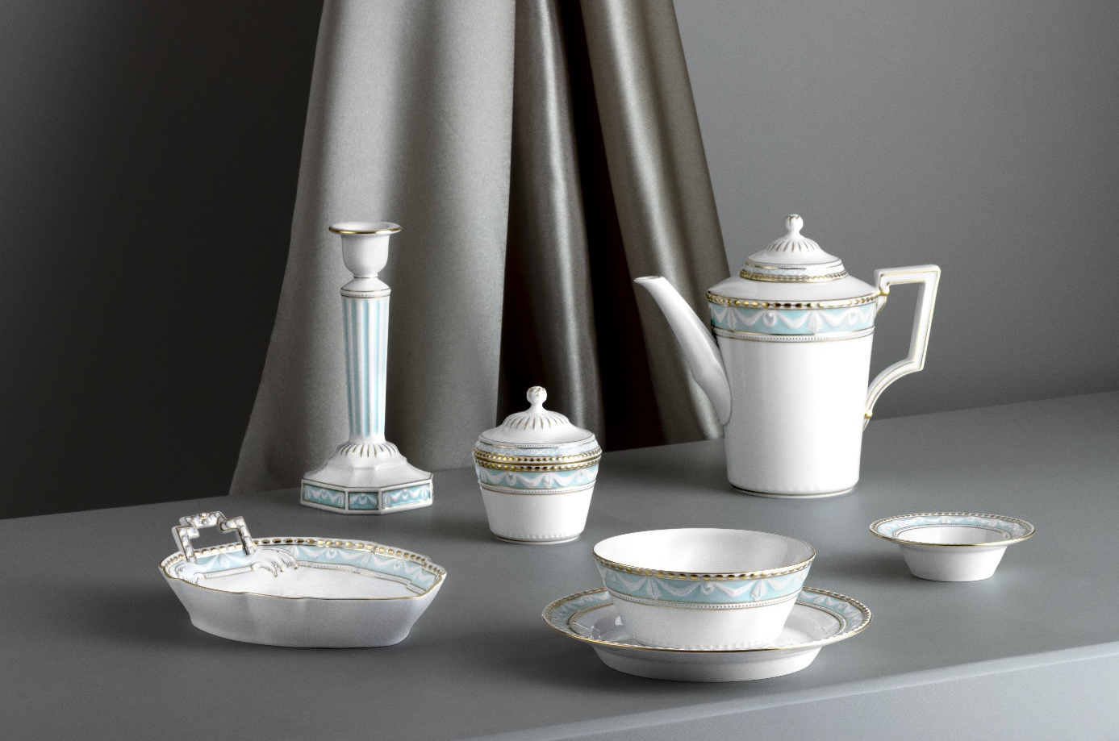The Königliche Porzellan-Manufaktur in Berlin has been producing tableware, decorative porcelain and porcelain art since 1763. Source: KPM Berlin.

As one of the oldest porcelain manufacturers in Germany, KPM has been producing high-quality tableware, decorative porcelain and porcelain art in Berlin since 1763 – exclusively by hand. In classic white, with a gold rim, hand-painted flower patterns, in classical shapes, modern designs or as figurines. The manufacturer's current range includes more than 2,000 different shapes, available in a variety of patterns. And thanks to the in-house design archive, each piece can still be reordered after decades. The exquisite porcelain from Berlin is just as much at home in luxury hotels and starred restaurants worldwide as it is on festively set tables at home.

The raw materials that make up the final product initially have nothing in common with the shiny end result. Of the three powders, kaolin is first dissolved in water. Once mixed, it has a buttermilk-like consistency that thickens slightly and absorbs the other two ingredients, feldspar and quartz. An agitator keeps everything moving and ensures a homogeneous mixture. Permanent magnets and fine sieves ensure that any unwanted particles do not cause unpleasant brown stains or pockmarks in the porcelain.

Constant vacuum for consistent quality

To further process the porcelain mixture, part of the water must now be removed. This is done in large filter presses. Here, the paths split between thrown porcelain, such as plates and cups, or slip-cast pieces, such as vases, jugs or figurines. For thrown goods, the paste is allowed to have a residual moisture content of 21-25%. The filter cake is transported to a two-stage screw extruder via a conveyor belt. Stage one presses the moist paste through punched sheet metal, creating thin, pasta-like strands – just like a meat grinder. These then fall into a vacuum chamber. Here, all air pockets are removed from the paste at a vacuum level of 20 hPa (mbar). Otherwise, when the porcelain is fired, these would expand and cause unsightly pockmarks or even cause the valuable pieces to burst.

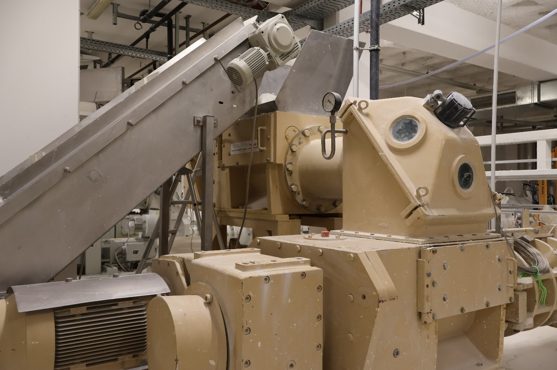
One of the three screw extruders that KPM uses to degas the porcelain paste. Source: Busch Vacuum Solutions.

"Thanks to the reliable vacuum generation of the R5 vacuum pumps from Busch, we can effectively deaerate (degas) our porcelain paste. This means that our cups, plates, and bowls emerge from the kiln in perfect condition. Only when there is constant pressure in the vacuum chamber can we consistently produce products of high quality," says Dr. Carsten Glitzky, Technical Manager at KPM. "To be honest, we don't put much work into our three vacuum pumps. We change the oil and filters at the recommended maintenance intervals. They don't need more maintenance than that," explains Dr. Glitzky with glee.

In the more fluid porcelain paste for slip-cast pieces, the air bubbles can escape with slight movements alone, something that is no longer possible with the more solid paste used for throwing. Vacuum from Busch has to provide support. The deaerated strands are pressed by a second screw through a conical mouthpiece into an endless strand. Its diameter depends on the size of the piece to be thrown – the smallest is used for an espresso cup, the largest for a dinner plate. A third vacuum pump on a separate extruder degasses special pastes for hand-thrown products such as large baskets.

No air bubbles in the kiln

The strands from the extruder are cut into 40 cm long slabs and stored in a damp room under tarpaulins. Just like in a greenhouse, a warm humid mist hangs in the air. They remain here for a few days until an employee picks them up and turns them into beautiful plates, cups, or bowls using traditional craftsmanship on a pottery wheel or with machine assistance.

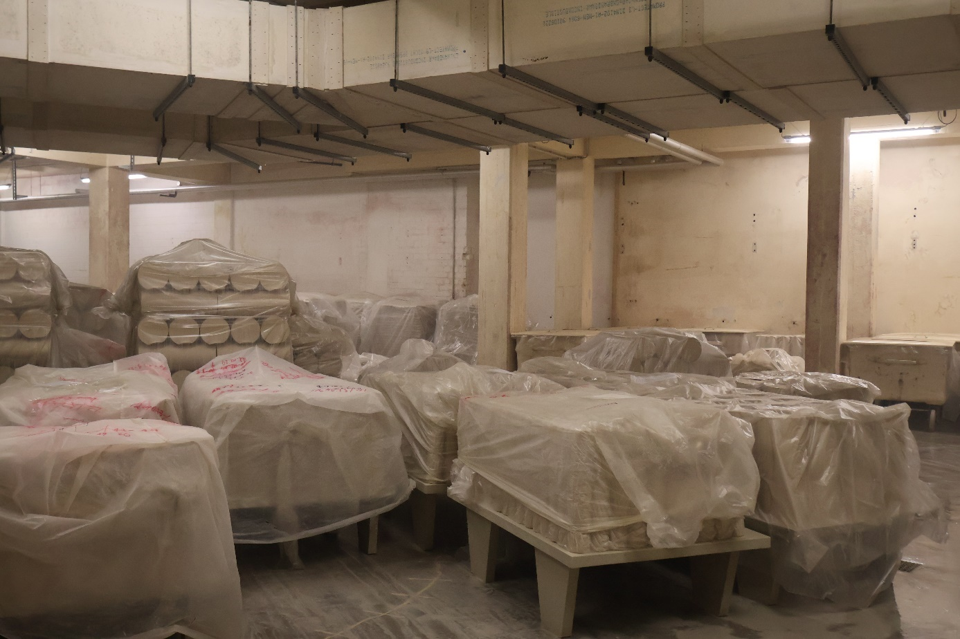
The porcelain slabs are stored in a “maukraum” (mauk-room) or aging room before being thrown by hand to create plates, cups and bowls. Source: Busch Vacuum Solutions.

This is followed by a drying phase and an initial firing at 1,000 °C to make the pieces more durable. Now they can be glazed and stamped with the company branding before the final firing at 1,400 °C over approximately 20 hours to give them their fine shine and final shape. When the large kiln door opens about four times a week after the final firing, it’s always an experience. The fearful question: Will everything come out of the kiln as expected when new designs are created? At least there are no unpleasant surprises caused by burst pieces, as the paste was degassed with vacuum from Busch.

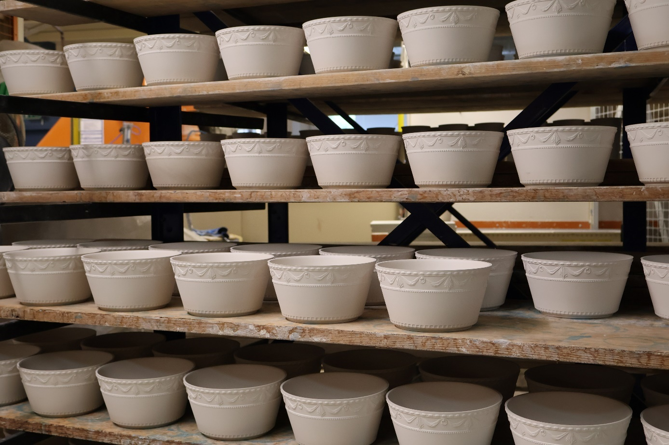
Bowls with the Kurland design wait for glazing and firing after they are thrown. Source: Busch Vacuum Solutions.

About the Busch Group

The Busch Group is one of the world’s largest manufacturers of vacuum pumps, vacuum systems, blowers, compressors and gas abatement systems. Under its umbrella, the group houses three well-known brands: Busch Vacuum Solutions, Pfeiffer Vacuum and centrotherm clean solutions.

The extensive product and service portfolio includes solutions for vacuum, overpressure and abatement applications in all industries, such as food, semiconductors, analytics, chemicals and plastics. This also includes the design and construction of tailor-made vacuum systems and a worldwide service network.

The Busch Group is a family business that is managed by the Busch family. More than 8,000 employees in 44 countries worldwide work for the group. Busch is headquartered in Maulburg, Baden-Württemberg, in the tri-country region of Germany, France and Switzerland.

The Busch Group manufactures in its 19 own production plants in China, the Czech Republic, France, Germany, India, Romania, South Korea, Switzerland, the United Kingdom, the USA and Vietnam.

The Busch Group has an annual consolidated revenue of close to 2 billion Euro.

Media Contact Details
Dr. Fabian Fahlbusch
Head of Content and Communications
Busch Vacuum Solutions
Schauinslandstrasse 1
79689 Maulburg, Germany

+49 (0)7622 681 - 3379
fabian.fahlbusch@busch.de
www.buschvacuum.com

